**Project Design Phase-II**

**Technology Stack (Architecture & Stack)**

|  |  |
| --- | --- |
| Date | 27 june 2025 |
| Team ID | LTVIP2025TMID31456 |
| Project Name | Health ai: Intelligent healthcare assistant using ibm granite |
| Maximum Marks | 4 Marks |

**Technical Architecture:**

Technical Architecture for the Health AI Intelligent Assistant using IBM Granite involves a multi-layered design including a user interface accessible via web and mobile platforms with chat and voice support. The application backend manages API requests, user sessions, and integrates external services such as Gmail and LinkedIn for authentication. At the core, IBM Granite Foundation Models power the AI/ML layer for natural language understanding, medical question answering, and contextual symptom analysis. Data is stored securely using encrypted databases and cloud object storage with full compliance to HIPAA and GDPR standards. **Example: Order processing during pandemics for offline mode**

Guidelines:

Include all the processes (As an application logic / Technology Block)

Provide infrastructural demarcation (Local / Cloud)

Indicate external interfaces (third party API’s etc.)

Indicate Data Storage components / services

Indicate interface to machine learning models (if applicable)

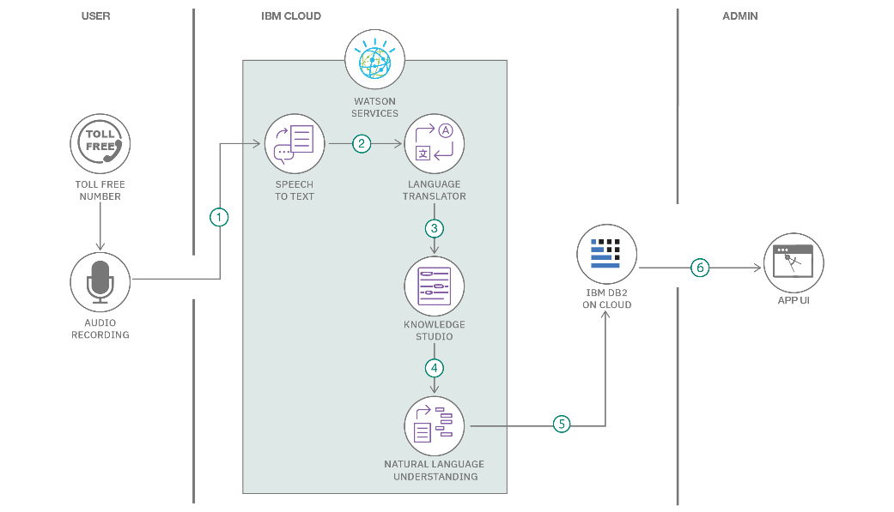

**Table-1 : Components & Technologies:**

|  |  |  |  |
| --- | --- | --- | --- |
| **S.No** | **Component** | **Description** | **Technology** |
|  | User Interface | How user interacts with application e.g.  Web UI, Mobile App, Chatbot etc. | HTML, CSS, JavaScript / Angular Js / React Js etc. |
|  | Application Logic-1 | Logic for a process in the application | Java / Python |
|  | Application Logic-2 | Logic for a process in the application | IBM Watson STT service |
|  | Application Logic-3 | Logic for a process in the application | IBM Watson Assistant |
|  | Database | Data Type, Configurations etc. | MySQL, NoSQL, etc. |
|  | Cloud Database | Database Service on Cloud | IBM DB2, IBM Cloudant etc. |
|  | File Storage | File storage requirements | IBM Block Storage or Other Storage Service or Local Filesystem |
|  | External API-1 | Purpose of External API used in the application | IBM Weather API, etc. |
|  | External API-2 | Purpose of External API used in the application | Aadhar API, etc. |
|  | Machine Learning Model | Purpose of Machine Learning Model | Object Recognition Model, etc. |
|  | Infrastructure (Server / Cloud) | Application Deployment on Local System / Cloud  Local Server Configuration:  Cloud Server Configuration : | Local, Cloud Foundry, Kubernetes, etc. |

**Table-2: Application Characteristics:**

| **S.No** | **Characteristics** | **Description** | **Technology** |
| --- | --- | --- | --- |
|  | Open-Source Frameworks | List the open-source frameworks used | Technology of Opensource framework |
|  | Security Implementations | List all the security / access controls implemented, use of firewalls etc. | e.g. SHA-256, Encryptions, IAM Controls, OWASP etc. |
|  | Scalable Architecture | Justify the scalability of architecture (3 – tier, Micro-services) | Technology used |
|  | Availability | Justify the availability of application (e.g. use of load balancers, distributed servers etc.) | Technology used |
|  | Performance | Design consideration for the performance of the application (number of requests per sec, use of Cache, use of CDN’s) etc. | Technology used |